Technology News: K – 6 Mrs. Greene  Contact Information: cbrown@bostonpublicschools.org  617-635-7945  What activities are we doing in class? Visit http://mlstechlab.weebly.com | December 2016

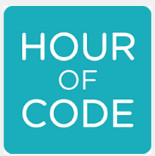  https://hourofcode.com/us |  | K2 proudly showing you can be a computer programmer at any age.  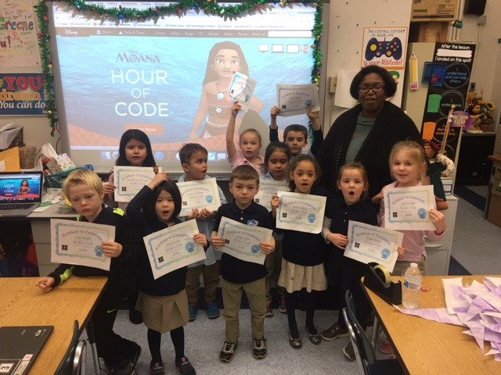
CC* Make strategic use of digital media Digital Learning Standard Computational Thinking CT.

For the third year in a row, students at the Mary Lyon show their computer programming skills as– 5 becoming computer programmers and joining students across the country and the world. The Hour of Code coincides with Computer Education Week. During December Mary Lyon students during Technology class learned how to code computer programs. Hour of Code hopes to take the mystery out of computer programming for students and help students build their logic, creativity and problem solving skills. Students were so excited about Hour of Code that we extended programming activities for the month of December. Students who completed a programming module received a certificate of completion. For more information about the Hour of Code go to https://hourofcode.com/us
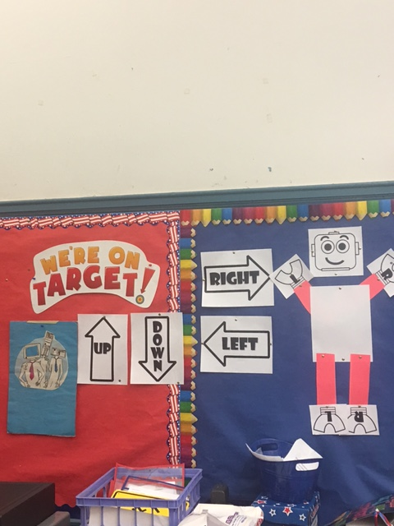 | 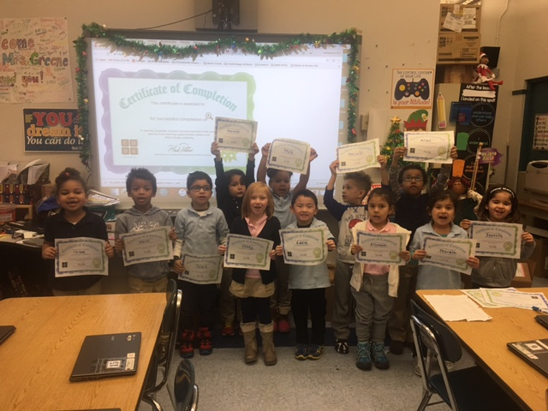 | Grade 3 students update the mlstechlab.weebly.com website.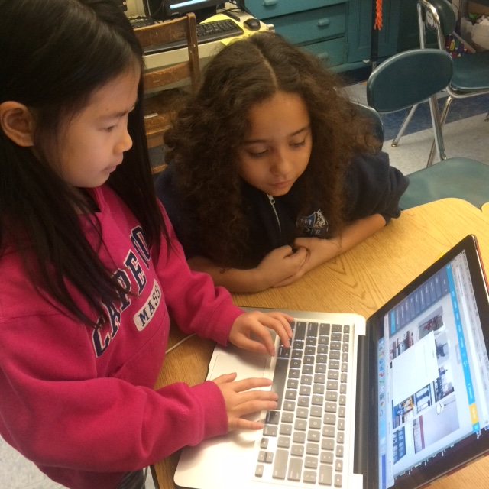 | Parent Notes
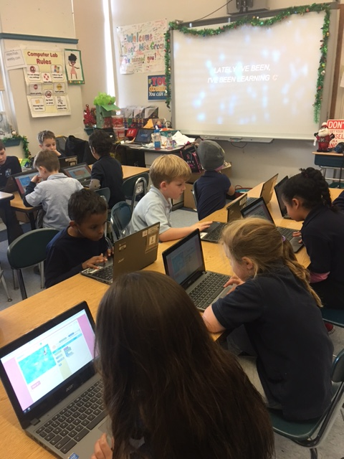 | 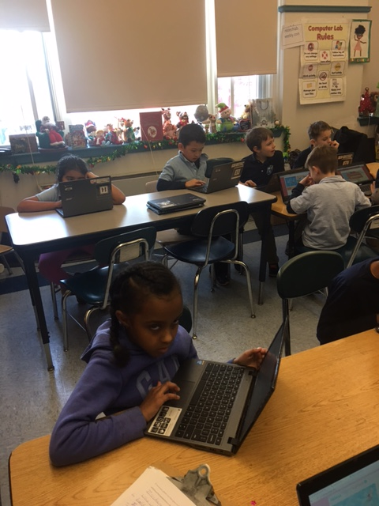 | 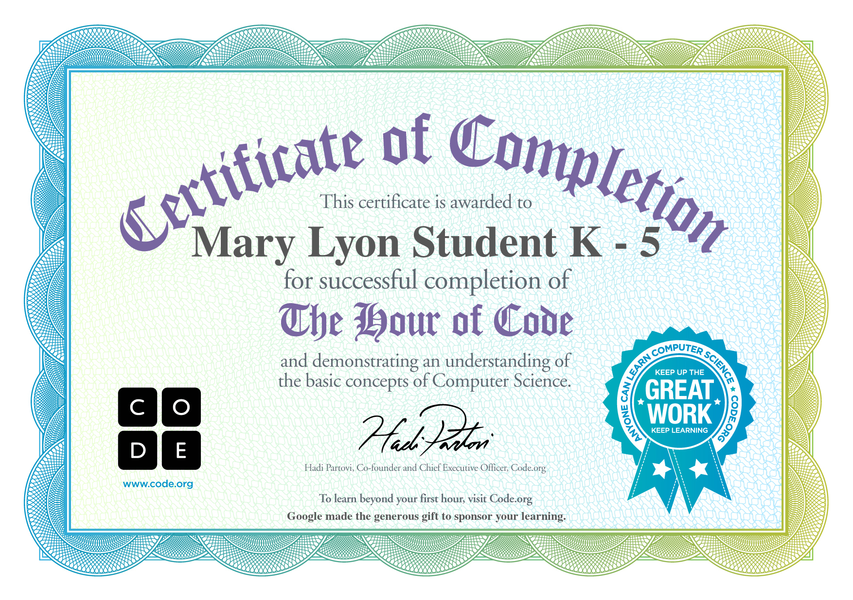 | For more opportunities for students to code visit  https://code.org/learn

Up and Coming:
- The Great Typing Challenge
- PARCC/MCAS technology prep.

Thank-Yous:
- I would like to thank everyone for their holiday well wishes and gifts.

Featured Websites and Apps to continue Computer Coding
- Daisy the Dinosaur app https://itunes.apple.com/us/app/daisy-the-dinosaur/id490514278?mt=8
- Kodable https://www.kodable.com/

*CC Common Core Standard

