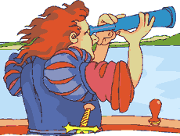

Explorer Assignments
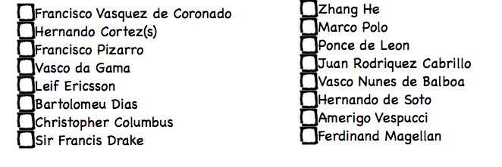
Francisco Vasquez de Coronado -
Hernando Cortez –
Francisco Pizarro –
Zhang He –
Leif Ericsson –
Bartolomeu Dias –
Sir Francis Drake –
Christopher Columbus -
Ponce de Leon –
Juan Rodriguez Cabrilla –
Vasco Nunes de Balboa –
Hernando de Soto –
Amerigo Vespucci –
Fernando Magellan –
Vasco de Gama –
Marco Pol0 -

